7COM1079-0901-2025 - Team Research and Development Project

Final report title: Gender Income Disparity in United States 1994

Group ID: 74 A

Dataset number: DS096 – adult income1.csv

Prepared by: Hariprasad Murugesan - 24135993,
Phani Muppalla – 24113322,
Hariharaan Murugesan Salaja - 24160923,
Prabhaharan Radhakrishnan - 24138313,
Rajath Krishna Naik - 24157852

University of Hertfordshire
Hatfield, 2025

Table of Contents

- Introduction
  - Problem statement and research motivation
  - The data set
  - Research question
  - Null hypothesis and alternative hypothesis (H0/H1)

- Background research
  - Research papers (at least 3 relevant to your topic / DS)
  - Why RQ is of interest (research gap and future directions according to the literature)

- Visualisation
  - Appropriate plot for the RQ output of an R script
  - Additional information relating to understanding the data
  - Useful information for the data understanding

- Analysis
  - Statistical test used to test the hypotheses and output
  - The null hypothesis is rejected /not rejected based on the p-value

- Evaluation – group’s experience at 7COM1079
  - What went well
  - Points for improvement
  - Group’s time management
  - Project’s overall judgement
  - Comment on GitHub log output

- Conclusions
  - Results explained.
  - Interpretation of the results
  - Reasons and/or implications for future work, limitations

- Reference list

- Appendices
- R code used for analysis and visualisation.
- GitHub log output.

- Introduction

  - Problem statement and research motivation (100 words)

Income inequality between men and women continues to be a prevailing issue in all most every country but for our research we choose United States. There are many research studies indicating that gender tends to affect earnings and subsequently access to higher-paying occupations. According to (Platt, et al., 2016) wage gap in gender causes mood disorders and depression. Men earn more than women even in traditionally female occupations, for example male registered nurses have historically out-earned female registered nurses. Considering these factors, we focus on testing these proportional differences to gain factual knowledge into gender-based income patterns using actual census data.

  - The data set (75 words)

The dataset used in this research is the Adult Income Census dataset, which contains 31,947 rows and 12 attributes, including age, education, occupation, race, sex, and category of income. It originates from the 1994 U.S. Census Bureau database and is one of the most extensively used datasets when studying income classification, demographic disparities, and social patterns in the United States.

  - Research question (50 words). State your RQ (50 words)

RQ: Is there a significant difference in the proportion of individuals earning less than 50K and more than 50K between males and females in the United States during 1994 ?
This question aims to determine whether income distribution in United States varies by gender when comparing the two standard income categories present in the adult income dataset during the year 1994.

  - Null hypothesis and alternative hypothesis (H0/H1) (100 words)

H0 (Null Hypothesis):

The null hypothesis (H₀) is that gender (male vs. female) and income category (<50K vs. >50K) are not related in the dataset. This means that any differences observed in the distribution of income categories between males and females occur purely by chance and cannot be attributed to gender.

H1(Alternative Hypothesis):

The alternative hypothesis (H₁) is that gender (male vs. female) and income category (<50K vs. >50K) are related. According to this hypothesis, gender influences the likelihood of belonging to either income category. Earlier studies using U.S. Census data have shown clear income differences between men and women, which is why it makes sense to test this idea (Blau, 2017).

- Background research

  - Research papers (200 words)

1)” The Gender Wage Gap: Extent, Trends, and Explanations.” (Blau, 2017)

The following article compares how men and women differ based on different wage levels, such as high, middle, and low earners. They focus mainly on the shares of males and females in each part of the wage distribution to show why women still earn less compared to men.

2)” Unequal depression for equal work? How the wage gap explains
gendered disparities in mood disorders” (Platt, et al., 2016).

In this journal, the authors group workers by income and compare the proportions between men and women in the lower and higher pay categories. Then, they relate these proportional differences in earnings to find differences in depression and anxiety rates between genders.

3) “Gender wage gap and its associated factors: An examination of traditional gender ideology, education, and occupation” (Langdon & Klomegah, 2013).

In this paper, they done statistical analysis using Chi-square and logistic regression then found that gender is a powerful predictor of earrings. The study shows that women were there times more likely them men to be in a low-income group (under $50,000). This gap persists even when controlling for education and occupation showing it’s not just about difference in job choices.

  - Why RQ is of interest (research gap and future directions according to the literature) (100 words)

This research question is important because gender-based income inequality remains one of the most concerning social and economic issues in the United States. Though earlier studies documented the gender wage gap, most focused on continuous income differences rather than proportional differences between defined income groups. While there are clear categories (<50K and >50K) in the adult dataset, the literature rarely investigates whether these proportions differ significantly by gender. This addresses a gap that shows more clearly how income is distributed across males and females.
Fairness research can be informed by this insight, policy discussions can be directed by it, and it points to structural disparities found in real census data.

- Visualisation

  - Appropriate graphs for the RQ output of an R script (50 words)

Fig 1. United States: Proportion of Gender within Income Brackets :

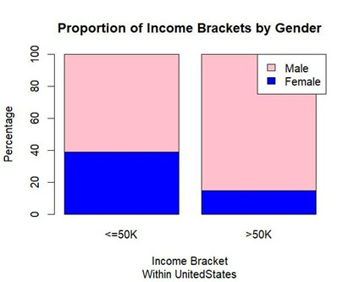

Fig 2. United States: Income category Distribution within Genders :

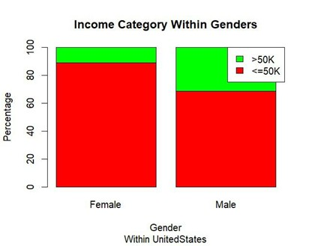

Contingency table:

United states: Sex vs Income Bracket Contingency table

 | <= 50K | >50K
Female | 8594 | 1068
Male | 13371 | 6087

Sample size: n = 29,120
Female: 9,662 total (93.3% earn <=50K)
Male: 19,458 total (68.7% earn <=50K)

For comparison of proportions analysis, we will use a chi-square test to check for the likelihood that there is a relationship between the two nominal variables. This non-parametric test makes no assumptions about the shape of the data (which is nominal, not interval) so we do not include a histogram for this test.

  - Additional information relating to understanding the data (optional) (50 words)

The bar plot clearly shows that males have a larger green section, meaning more of them earn over 50K. The contingency table supports this with actual numbers, confirming that the pattern seen in the chart is backed by data and suitable for the chi-square test.

  - Useful information for the data understanding (50 words)

The plot clearly shows that most women fall into the ≤50K income group, while men appear more often in the >50K range. Although both genders mostly earn below 50K, men are still more likely to be high earners. This trend suggests gender may influence income levels.

- Analysis:

  - Statistical test used to test the hypotheses and output (75 words)

We applied Pearson’s Chi-square test of independence to the United States contingency table because both variables male, female and income bracket which is 1(≤50K), 2(>50K) is nominal. Our research question clearly asks whether the income proportions differ by gender, so a proportions-based test is essential. The Adult Income dataset supplies large cell counts, satisfying the expected frequency assumption and justifying a non-parametric test that does not impose distributional constraints on categorical data.

  - The null hypothesis is rejected /not rejected based on the p-value (100 words)

The test with United-States produced x^² = 1424.4 with df = 1 and p < 2.2×10^-16, far below alpha = 0.05. Therefore, we rejected the null hypothesis of equal income proportions across genders. Practically only about 11 % of females fall in the >50K bracket, compared with roughly 31 % of males, indicating a strong gender income gap. Because the sample size is approximately about 32000 records, the result is statistically robust and most likely it is not a sampling fluke. This effect also has real world meaning - males dominate high income positions, while females are concentrated in the ≤50K category, implying the need to explore other causes.

- Evaluation – group’s experience at 7COM1079

  - What went well (75 words)

Our group coordinated well together, and everyone communicated clearly during the project. We split the tasks for each member fairly, and each member contributed in a useful way. Choosing the United States as our only country simplified our workflow and let us deepen the narrative. The feedback we received in tutorial sessions also helped us correct our approach early and simplified the rest of the work.

  - Points for improvement (75 words)

Initially, we ended up unnecessarily working with many countries from the dataset and later decided to remove them from the scope. At times, we also found it difficult to sync up due to our different schedules, which caused some tasks to be delayed beyond the planned time. To address this, we started connecting via Google Meet three times a week to keep track of progress. This improved our coordination and ensured timely delivery.

  - Group’s time management (50 words)

Overall, our time management was good since we completed the important tasks on time. However, in some cases, making sense of the results and finalising slides took longer, costing us roughly 2–3 working days more. Setting up weekly goals or using a shared checklist might help us stay more organised and finish tasks earlier.

  - Project’s overall judgement (50 words)

Our United States only project was executed well by us. The cleaned data, chi-square test, bar charts, and statistics all obviously point toward the same gender pay gap. Even though we initially had some issues, our final execution was strong, and we learned and sharpened many new skills.

  - Note any changes to group since original allocation if applicable. Add new or amended GitHub Ids for new members (75 words, write only if applies to your group arrangements)

No changes occurred after the original allocation; all members and GitHub handles remain as initially registered.

  - Comment on the GitHub log output (50 words)

Appendix B Section 8 highlights the log snippet. Key entries include:
- One team member handled coding and statistical analysis.
- Another focused on visualization and analysis.
- Other remaining members equally prepared the report.
- All collaborated, supported each other, documented details in Git, and contributed equally throughout the project

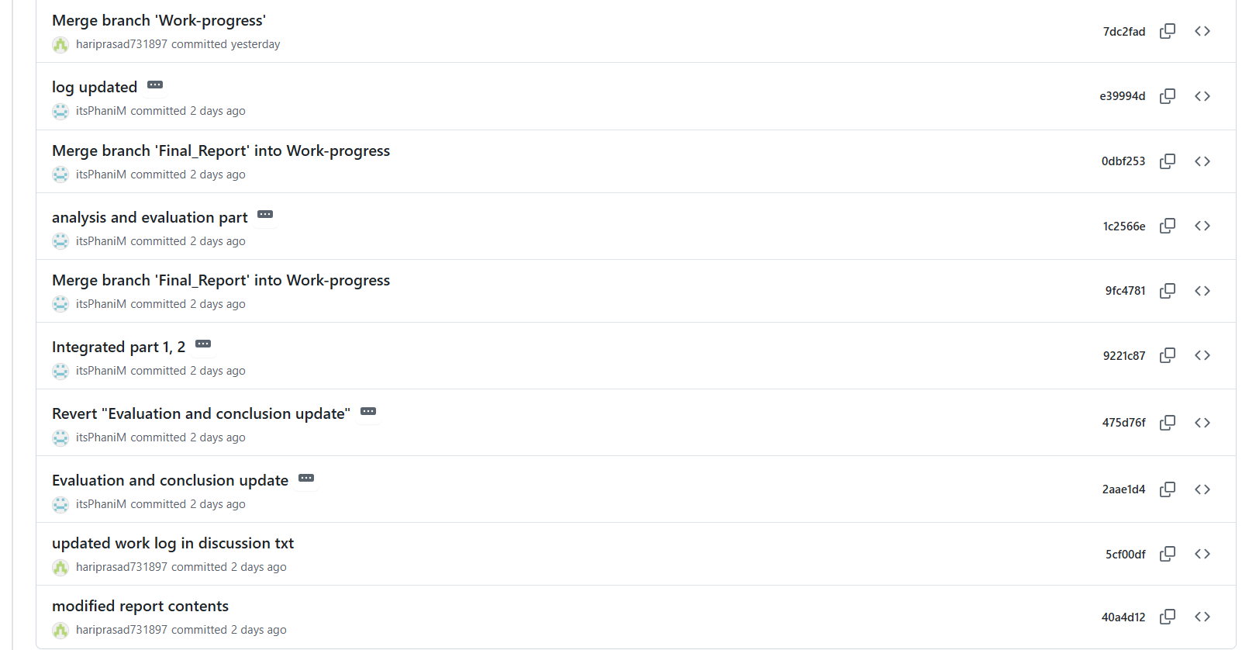

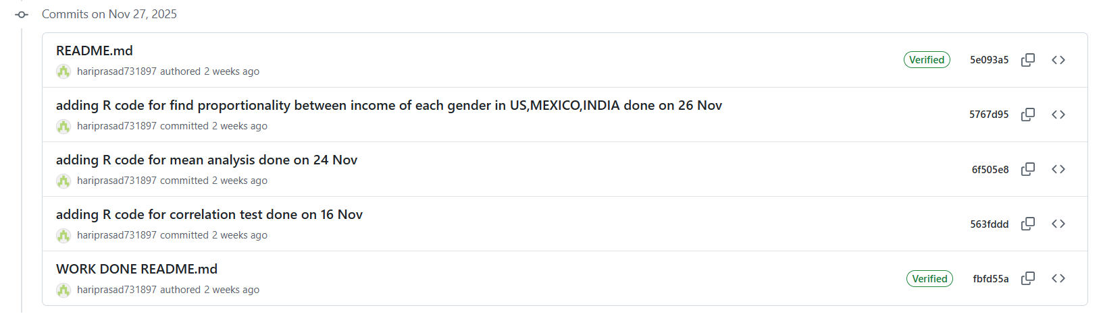

- Conclusions

  - Results explained (75 words)

The United States contingency table shows starkly different distributions: 93% of women versus 69% of men earn ≤50K, while 31% of men but only 11% of women surpass 50K. Pearson’s Chi-square statistic of 1424.4 (df = 1, p < 2.2×10^-16) confirms the gap is not due to sampling noise. Because the contingency counts, visualization, and statistical output were derived from the same cleaned DS096 subset, every strand of evidence narrates the same message.

  - Interpretation of the results (75 words)

Rejecting the null hypothesis confirms that there is a link between gender and income. Specifically, men are three times more likely to earn over $50k, demonstrating a gender pay disparity. Furthermore, visual evidence from bar charts and chi square test results validates this significant disparity.

  - Reasons and/or implications for future work, limitations of your study (50 words)

We only used one segment of the data and a basic two variables to test, so we couldn’t control for other variables like education, marital status or occupation. Next time we’d would include with those factors, check trends over time, and maybe gather qualitative notes to see why the gap persists.

- References:

1. Blau, F. D. K. L. M., 2017. The gender wage gap: Extent, trends, and explanations. Journal of economic literature, 55(3), pp. 789-865.
Available at: https://www.aeaweb.org/articles?id=10.1257%2Fjel.20160995&trk=article-ssr-frontend-pulse_x-social-details_comments-action_comment-text [Accessed: 09/12/25]

2. Langdon, D. L. & Klomegah, R., 2013. Gender wage gap and its associated factors: An examination of traditional gender ideology, education, and occupation. International Review of Modern Sociology, pp. 173-200.
Available at: https://www.jstor.org/stable/43496468?seq=1 [Accessed: 09/12/25]

3. Platt, J., Prins, S., Bates, L. & Keyes, K., 2016. Unequal depression for equal work? How the wage gap explains gendered disparities in mood disorders. Social Science & Medicine, Volume 149, pp. 1-8.
Available at: https://www.sciencedirect.com/science/article/pii/S0277953615302616
[Accessed: 09/12/25]

- Appendices

- R code used for analysis and visualisation:
# Import data
library(readr)
df <- read_csv("adult income1.csv")

# Clean and filter dataset to only include 'Male' and 'Female'
df2 <- subset(df, sex == "Male" | sex == "Female")
df2 <- subset(df, native.country == "United-States" )

# Create a new binary column for income bracket
df2$income_bracket <- ifelse(df2$income == "<=50K", "<=50K", ">50K")

# Build a contingency table: Gender vs Income bracket
usa<- table(df2$sex[df2$native.country=="United-States"], df2$income_bracket[df2$native.country=="United-States"] )

# Chi-squared test for difference in proportions
chisq.test(usa)

# Convert counts to percentages by column: proportion inside each income group
percentages <- prop.table(usa, margin=2) * 100

# Plot: Stacked bar chart of gender proportions inside each income group
barplot(percentages, col = c("orange", "black"), xlab = "Income Bracket", ylab = "Percentage",
main = "Proportion of Income Brackets by Gender", ylim = c(0, 100),
legend.text = rownames(usa), args.legend = list(x = "topright"),sub = "Within UnitedStates")

# Optional: Also view proportions within each gender (transpose for barplot)
tpercentages <- prop.table(t(usa), margin=2) * 100
barplot(tpercentages, col = c("red", "green"), xlab = "Gender", ylab = "Percentage",
main = "Income Category Within Genders", ylim = c(0, 100),
legend.text = colnames(usa), args.legend = list(x = "topright"),sub = "Within UnitedStates")

- GitHub log output.

